- Troubleshooting Tools

Q1. Open the command prompt and use the ipconfig tool to find your computer's IPv4 address and default gateway, then take a screenshot of the output?

Answer

- Finding IPv4 Address and Default Gateway Using ipconfig
I opened Command Prompt and used the following command:
ipconfig
From the active Wi-Fi adapter, I found:
- IPv4 Address: 10.219.126.234
- Subnet Mask: 255.255.255.0
- Default Gateway: 10.219.126.141
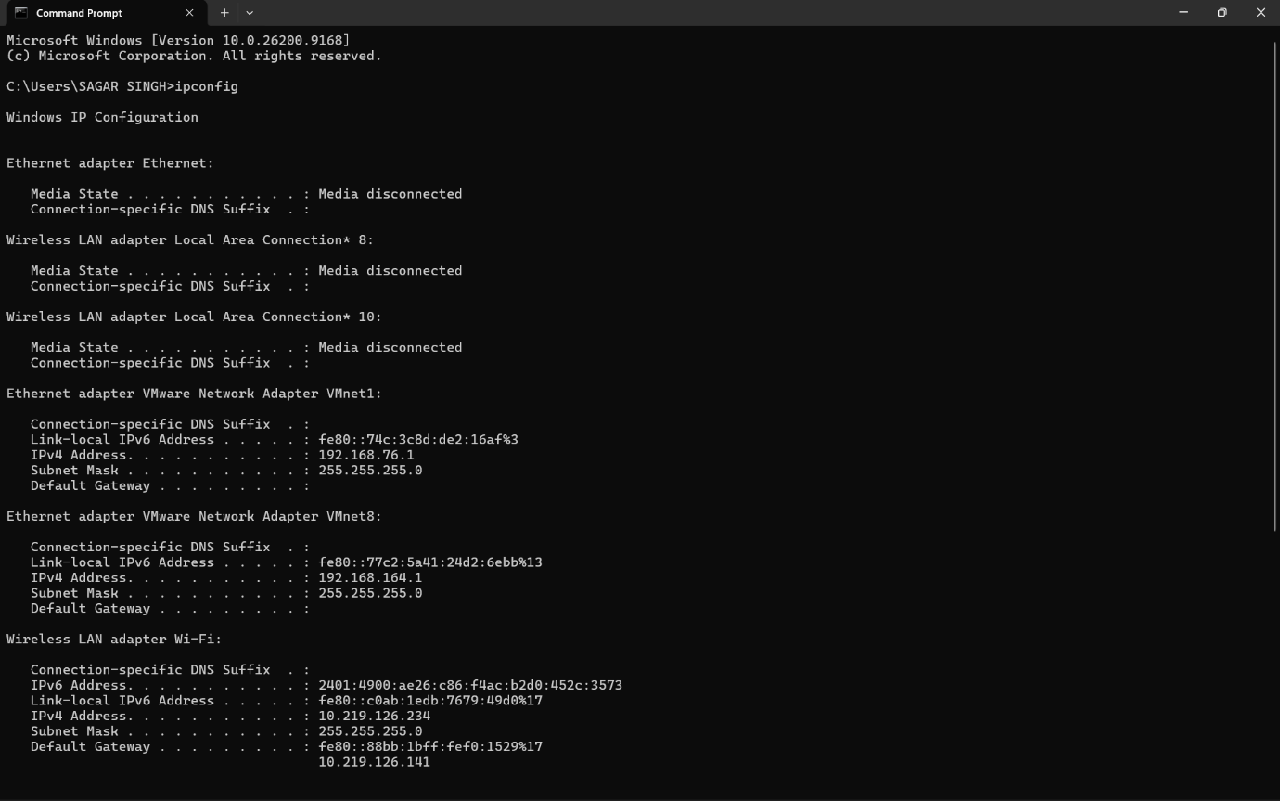
- Result:
The ipconfig command successfully displayed my computer’s current IPv4 address and default gateway.

Q2. Use the ping command to check the connectivity between your computer and www.google.com, then note down the average response time shown?

Answer

- Ping Test to Google
I used the ping command to test connectivity to www.google.com.
ping www.google.com
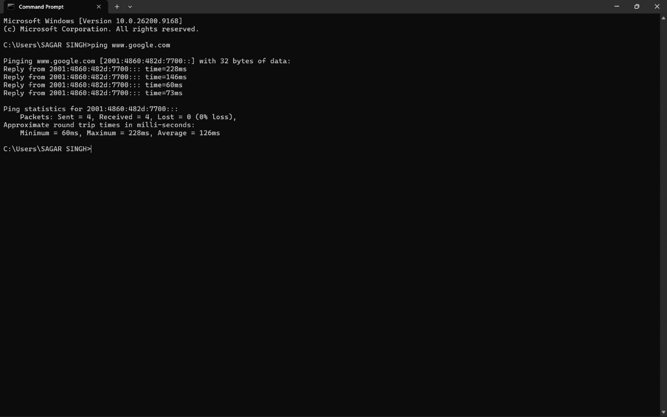
Average Response Time: 126 ms
Packet Loss: 0%
- Result:
The ping test was successful, and the average response time to Google was 126 ms.

Q3. Run the tracert (or traceroute on Linux/Mac) command to www.flipkart.com and list the number of hops it takes to reach the destination?

Answer

- Traceroute to Flipkart
I used the following command to trace the route to Flipkart:
tracert www.flipkart.com
The trace completed successfully and reached the destination in 15 hops.
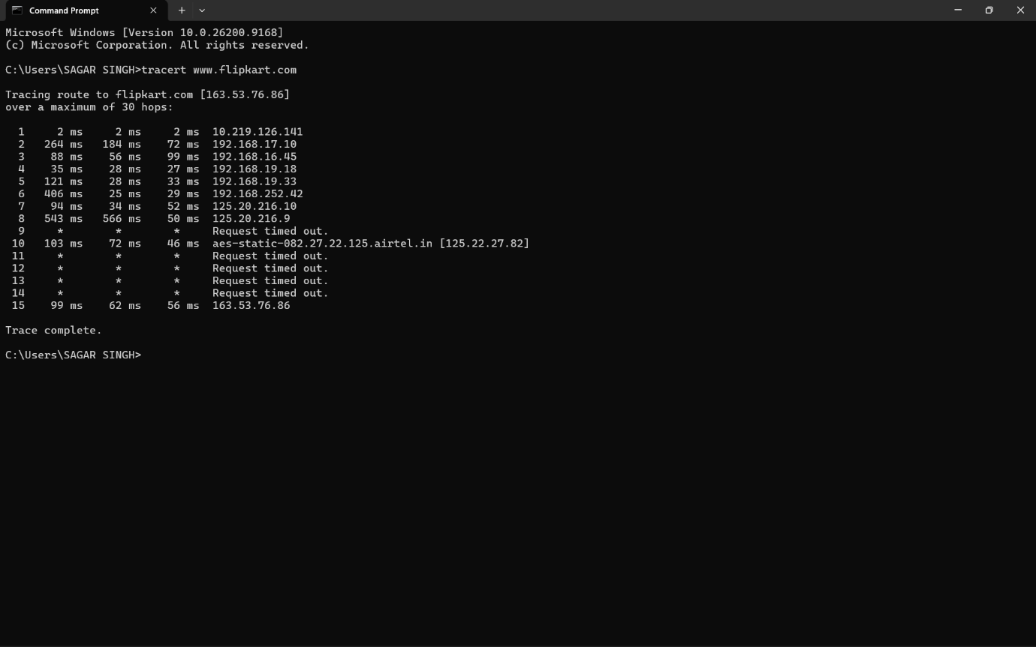
Some intermediate hops showed Request timed out, which can happen when certain routers do not reply to traceroute requests.
- Result:
The destination was reached successfully after 15 hops.

Q4. Use the nslookup tool to find the IP address of www.spotify.com and explain in one line what this tool helps you verify?

Answer

- Finding Spotify IP Address Using nslookup
I used the following command:
nslookup www.spotify.com
The result returned:
- IPv4 Address: 151.101.211.42
- IPv6 Address: 2a04:4e42:31::810
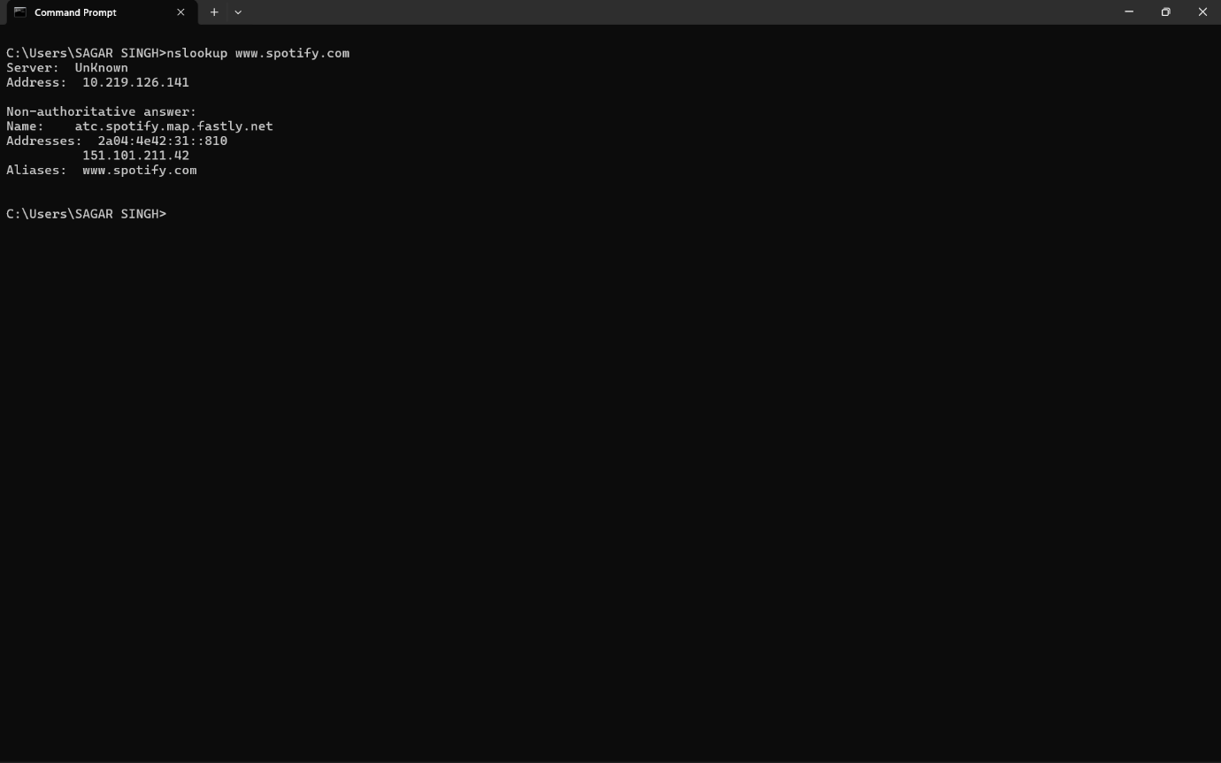
- One-line explanation:
nslookup helps verify whether a domain name is correctly resolving to an IP address through DNS.

- Result:
The Spotify domain was successfully resolved to its IP addresses.

Q5. A friend says they cannot access Zomato’s website from their laptop. Suggest a sequence of three troubleshooting commands (choose from: ping, ipconfig, tracert, nslookup) you would run to diagnose the issue, and briefly state what each command would help you check.<br><br><em><strong>Hint:</strong> Think about checking both network connectivity and DNS resolution.</em>?

Answer

- Troubleshooting Zomato Website Access
If my friend cannot access Zomato’s website, I would use these three commands in this order:
- ipconfig
This checks whether the laptop has a valid IP address, subnet mask, and default gateway. If these are missing or incorrect, the laptop may not be connected properly to the network.
- ping www.zomato.com
This checks whether the Zomato website is reachable over the network. If the ping fails, there may be a connectivity or routing problem.
- nslookup www.zomato.com
This checks whether the domain name is resolving correctly to an IP address. If it fails, the problem may be related to DNS.
- Conclusion:
These commands help check the laptop’s network configuration, internet connectivity, and DNS resolution step by step.

